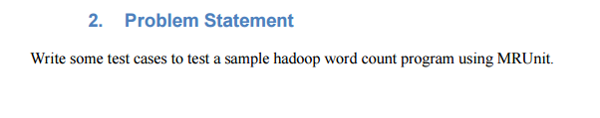

**Step1**: First we will create a word count sample program.

*Driver*

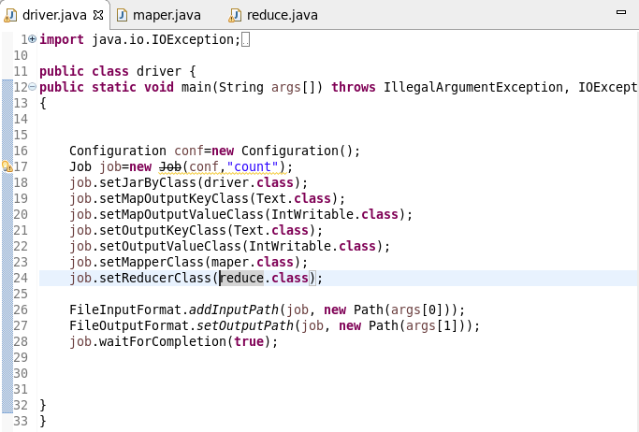

*Mapper :*

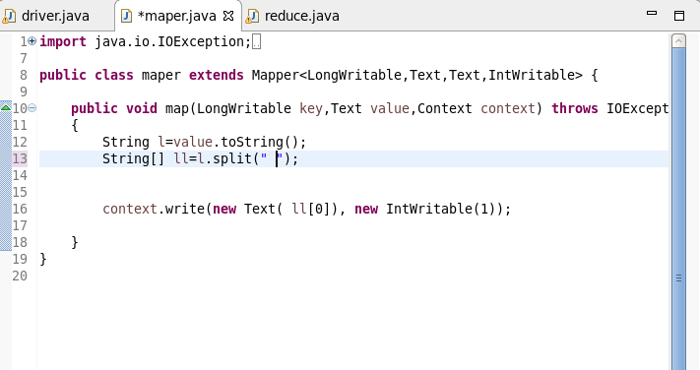

***Reducer***

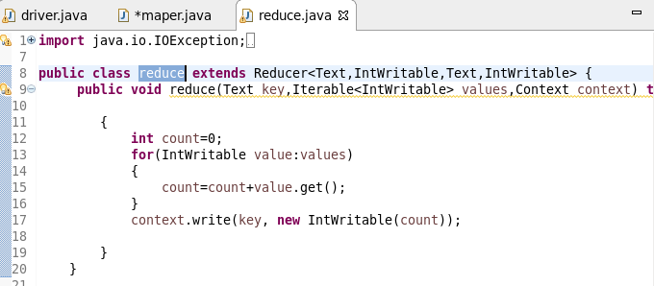

**Step2:** After creating word count , we will give some test cases using MR unit.

**Step3:** Specifying Mapper,Recucer,Driver(key value pair)

**Step4 :** In Setup Method we will Set up Instance of Mapper and Reducer which needs to be Tested

In MapReduceDriver

**Step5:**

**TESTING MAPPER**: In Test Mapper Method,give Input for the mapper by using **withInput()**

and give the Expected Output in withOutput()

**For Example**

If Input is (Australia,Newzealand,America)

**Expected Output is**

(Australia,1)

(Newzealand,1)

(America,1)

**mapDriver.runTest()**  will run the configured Mapper with the input and the expected output. If the output from the Mapper for the given input is same as the provided output the test will report a success or it will fail.

***TESTING REDUCER****:* In Test class,give Input for the reducer by using **withInput()**

and give the Expected Output in **withOutput()**

**For example** (Australia,list of values)

*Expected Output*

(Australia,2)

**ReduceDriver.runTest()**  will run the configured Mapper with the input and the expected output. If the output from the Mapper for the given input is same as the provided output the test will report a success or it will fail.

*Testcase 1:*

**The Input and expected Output are Matching So the test case run without any error as seen in left side**

**Map INPUT (Australia,Australia,newzealand)**

**Output (australia,1)**

**(australia,1)**

**(newzealand,1)**

As the Order is correctly given The test case did not fail

**Reducer**

**Input (australia,1,1)**

**Output(australia,2)**

**As the expected Output IS given test case did not fail**

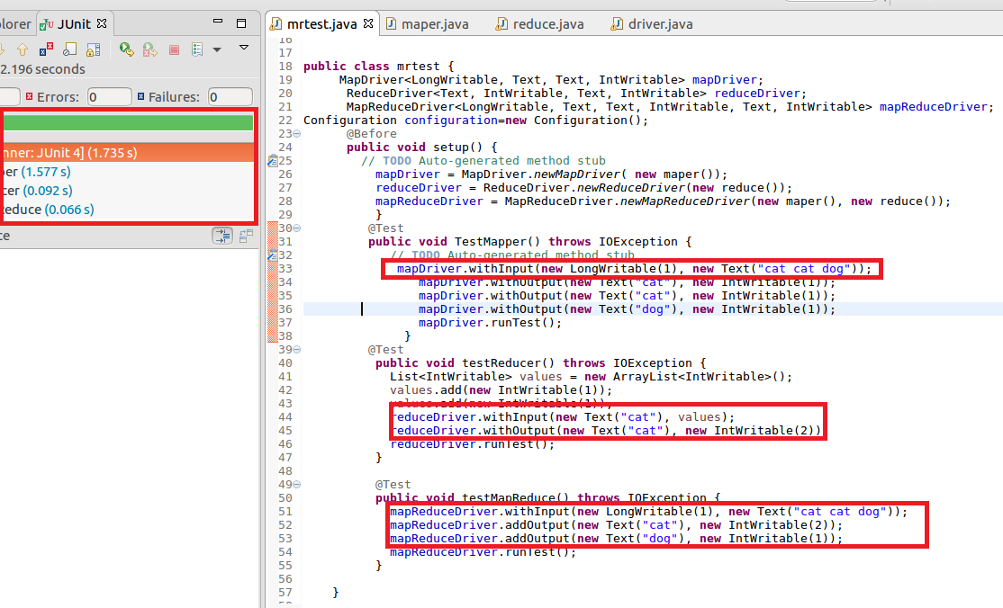

*Test Case 2:*

**In Test case 2 failure Occurs due to wrong Output given in Mapper as highlighted below**

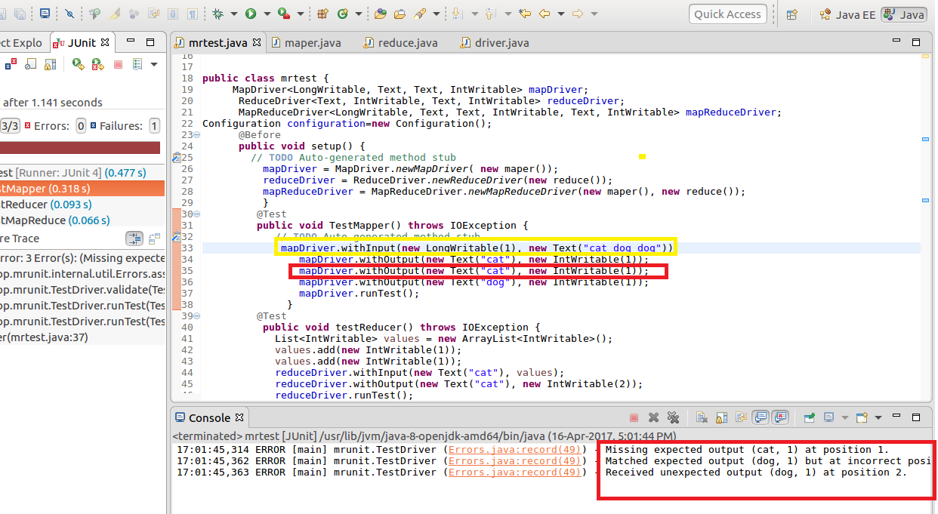

**Inference : At position 1(index start from 0),banana 1 is expected**

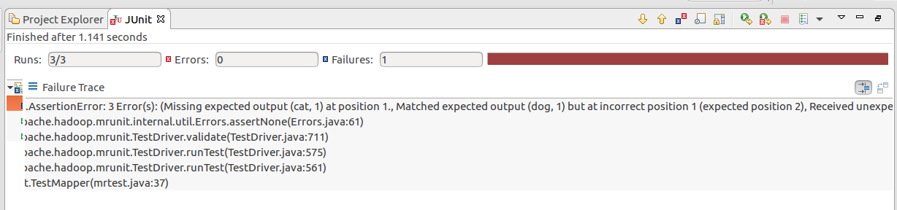

*TestCase 3:*

**In test case 3 Failure Occurs Due to reducer**

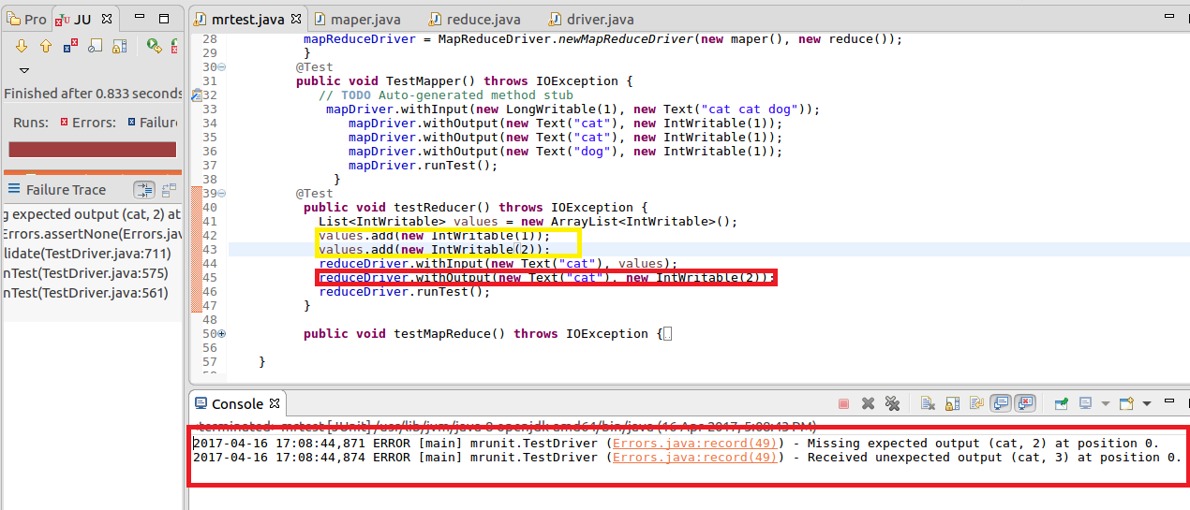

*Test case 4:*

**Case fails due to Overall output error**

